HTML Injection
# Source: AI Source: Provided by: [Data Path: Persons Table -> ID Column: 1, Name_En Column: Motasem Essam] -> From: [Chatgpt (GPT‑5 Mini)] on [1/20/2026]
HTML Injection is a type of code injection vulnerability where an attacker inserts malicious or unexpected HTML code into a web page. If the application includes untrusted user input in its HTML output without proper sanitization, an attacker can inject custom HTML that changes how the page appears or behaves.

🔎 Why It's Dangerous
# Source: AI Source: Provided by: [Data Path: Persons Table -> ID Column: 1, Name_En Column: Motasem Essam] -> From: [Chatgpt (GPT‑5 Mini)] on [1/20/2026]
HTML Injection can lead to:
- Content Spoofing (fake messages or pages)
- UI redress attacks (fake login forms)
- Phishing attacks
- Cross-Site Scripting (XSS) if JavaScript is injected or enabled through HTML

🧪 Example of HTML Injection
# Source: AI Source: Provided by: [Data Path: Persons Table -> ID Column: 1, Name_En Column: Motasem Essam] -> From: [Chatgpt (GPT‑5 Mini)] on [1/20/2026]
Vulnerable HTML:

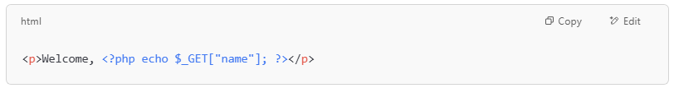
<p>Welcome, <?php echo $_GET["name"]; ?></p>

Malicious input:
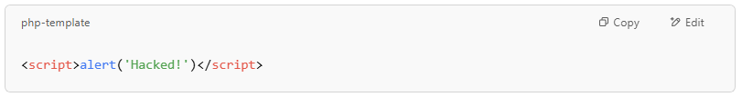
<script>alert('Hacked!')</script>

Output: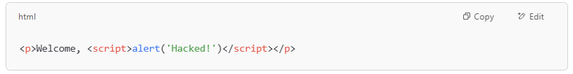
<p>Welcome, <script>alert('Hacked!')</script></p>

💥 This will pop an alert — a basic XSS attack.

🧪 Less Obvious Example
# Source: AI Source: Provided by: [Data Path: Persons Table -> ID Column: 1, Name_En Column: Motasem Essam] -> From: [Chatgpt (GPT‑5 Mini)] on [1/20/2026]
User inputs:
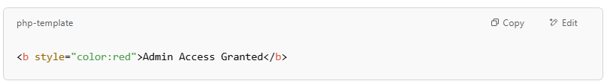
<b style="color:red">Admin Access Granted</b>

Output:
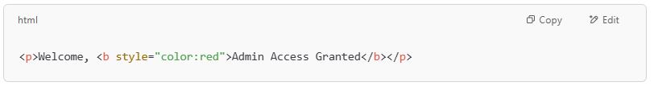
<p>Welcome, <b style="color:red">Admin Access Granted</b></p>

📌 This might fool users into thinking they have admin access — a classic content spoofing scenario.

🔒 How to Prevent HTML Injection
# Source: AI Source: Provided by: [Data Path: Persons Table -> ID Column: 1, Name_En Column: Motasem Essam] -> From: [Chatgpt (GPT‑5 Mini)] on [1/20/2026]

Prevention Technique | Description
✅ HTML Escaping | Convert <, >, &, ', " to &lt;, &gt;, etc., before rendering user input
✅ Input Sanitization | Strip or reject dangerous HTML tags/attributes
✅ Use Trusted Templating Engines | Many frameworks automatically escape output (e.g., Handlebars, Django templates)
✅ Content Security Policy (CSP) | Restricts what scripts and content can run in the browser

✅ Safe Output Example (Escaped)
# Source: AI Source: Provided by: [Data Path: Persons Table -> ID Column: 1, Name_En Column: Motasem Essam] -> From: [Chatgpt (GPT‑5 Mini)] on [1/20/2026]
If user input is: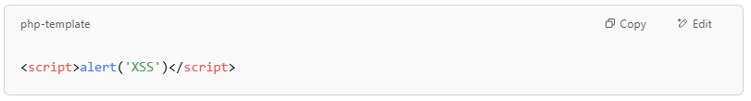
<script>alert('XSS')</script>

Escaped version:
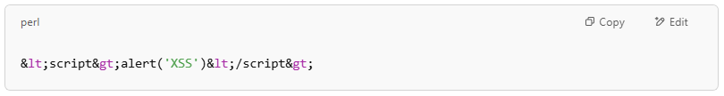
&lt;script&gt;alert('XSS')&lt;/script&gt;

So the browser shows it as text, not code.

🔐 Summary
# Source: AI Source: Provided by: [Data Path: Persons Table -> ID Column: 1, Name_En Column: Motasem Essam] -> From: [Chatgpt (GPT‑5 Mini)] on [1/20/2026]
Vulnerability | HTML Injection
Affects | Web page content and layout
Risk | Phishing, spoofing, XSS
Caused by | Outputting unescaped user input in HTML
Prevention | Escape HTML output, sanitize input, use safe templates

